SUMMER ASSIGNMENT FOR AP ENVIRONMENTAL SCIENCE

Dear Students, welcome to Advanced Placement Environmental Science (APES).

Download and read the APES course and exam description (CED),
https://apcentral.collegeboard.org/courses/ap-environmental-science

For summer work, please complete the document by answering questions and send it to sdogru@tmsacademy.org.

Part 1: Experimental Design
Answer the following questions using the following statement, your knowledge of experimental design and the graph below. Need a refresh on experimental design?
Watch this video or this one.

A clam farmer has been keeping records concerning the water temperature and the number of clams developing from fertilized eggs. The data is recorded below.
Water Temperature in ºC | Number of developing clams
15 | 75
20 | 90
25 | 120
30 | 140
35 | 75
40 | 40
45 | 15
50 | 0

a) What is the dependent variable?

b) What is the independent variable?

c) What is the optimum (best) temperature for clam development?

d) What is the average temperature in this experiment?

e) What are some constants the scientists should consider?

Part 2: Math Skills
Reminders
- Write out all your work, even if it’s something really simple. This is required on the AP ENVS exam so it will be required on all your assignments, labs, quizzes, and tests as well.
- Include units in each step. Your answers always need units and it’s easier to keep track of them if you write them in every step.
- Check your work. Go back through each step to make sure you didn’t make any mistakes in your calculations. Also check to see if your answer makes sense. For example, a person probably will not eat 13 million pounds of meat in a year. If you get an answer that seems unlikely, it probably is. Go back and check your work.
- You may use a calculator but will not be provided with a formula sheet.
Metric Units: YOU MUST MEMORIZE THE METRIC CONVERSION CHART
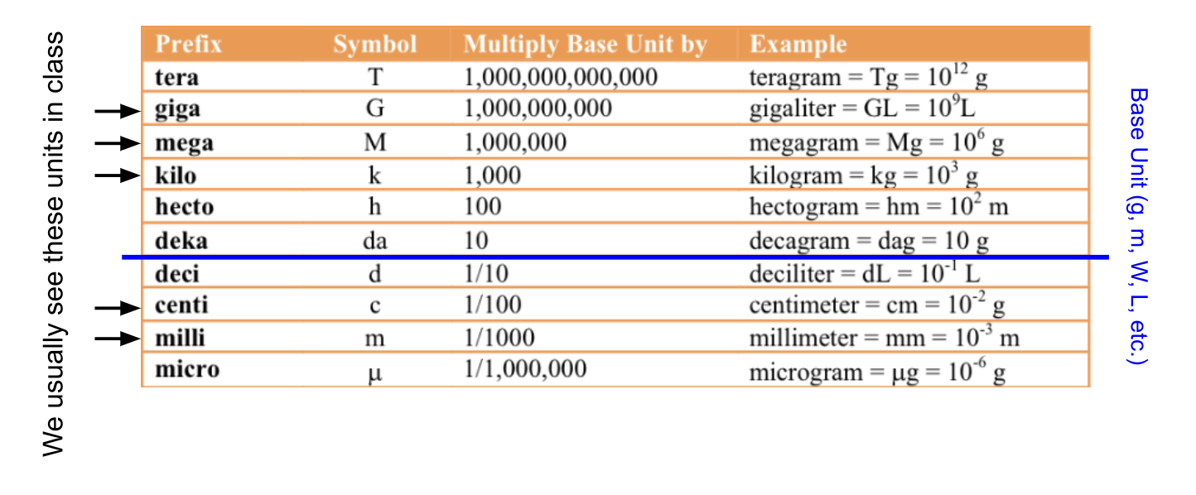
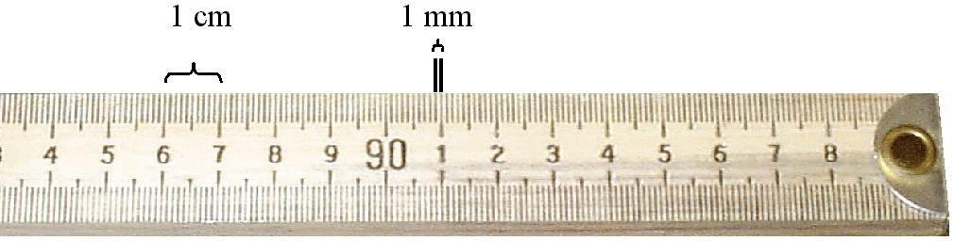
1. How many mm are in a centimeter?

2. How many centimeters are in a meter?
(The prefix centi- means 100. How many cents (pennies) are in a dollar?)

3. The prefix milli- means a thousand. How many millimeters are in a meter?
Percent Change = ( New – Original ) X 100
Original

4. If you scored a 1090 on your first PSAT and 1210 on your second PSAT. What was your percent improvement?

5. If one termite can destroy 1.2mg of wood per day, how many kilograms of wood can 10 termites destroy in 1 week?

6. What is 70% of 640?

7. 400 kilograms = ___________________milligrams

8. 600 mm = ______________________ cm

9. 25 MW = _______________ W

Write the following in scientific notation

10. 394 billion 11. 0.000070202

12. If I can run 6 km in 24 minutes, how many cm can I run in 5 hours?

13. Fourteen percent of a 55,000 acre forest is destroyed by the invasive pine weevil. How many acres of the forest were not destroyed?

14. A pesticide was sprayed on a portion of a forest. The pesticide killed 25,000 termites. This is 71% of the local termite population. What is the total termite population?

Part 3. Laws to know; explain each of the following laws.

- Clean Air Act
- Clean Water Act
- Safe Drinking Water Act (SDWA)
- Comprehensive Environmental Response, Compensation, and Liability Act (CERLA aka Superfund Act)
- Resource Conservation and Recovery Act (RCRA)
- Montreal Protocol
- Convention on International Trade in Endangered Species of Wild Fauna and Flora (CITES)*
- Kyoto Protocol*
- Endangered Species Act (ESA)*
- Delaney Clause Of Food, Drug, And Cosmetic Act*

Part 4. Listen to the following TedTalk by environmentalist Stewart Brand and answer the questions below:

https://www.ted.com/talks/stewart_brand_the_dawn_of_de_extinction_are_you_ready

a. Describe the main difficulties (e.g., technologically, biologically, ethically) with “resurrecting” an extinct species.

b. Explain why the genomes of older extinct species (i.e., ones that have been extinct longer) are more difficult to reconstruct than those of more recent extinctions.

c. What would be the benefit of bringing back an extinct species? What could be some drawbacks or detriments?

d. Discuss your opinions on this technology. If it can be done, should it be done?
(Note: opinions are not just okay here, but encouraged; but base them on your current understanding of the science/technology)?

e. If you could “de-extinct” any one species from Earth’s history (ignoring all technological challenges), which would you choose? Why?

Part 5 – Calculate your ecological footprint and note how many planets do we need if everybody lives like you?
https://www.footprintcalculator.org/home/en

